NOVIGRAD CITTANOVA RUN 2026
(Novigrad, Istra)

- half-marathon (21km)
- 10km race
- 5km race
- FUN RUN 200m and 500m kid's races

ORGANISER:
Aminess Hotels & Resorts

DATE:
Sunday, 29. November 2025.

RACES START:
Aminess Vival Maestral Hotel

5km race start: 11:30 AM
10km and half-marathon races start: 11:00 AM
Kid's races FUN RUN: 10:30 AM
Race director: Nenad Popović
Organiser’s official website: www.aminess.com

Organiser’s contact: Nenad Popović,
+385/52/858-650, nenad.popovic@aminess.com

Contact for all information: reservations@aminess.com

VENUE:
Town of Novigrad; promenade, waterfront, old town centre, Mareda village and Aminess Maravea Planet Camping Resort, Dajla village

HALF-MARATHON
Half-marathon is 21 098m long and the race has one lap.

Start/finish line: In front of the Aminess Vival Maestral Hotel
Race start: 11:00 AM
Control point: 10km

Important notice:
Half-marathon runners will start together with 10km race runners. They will separate from the 10km race on the fifth kilometre of the route where race judges and organiser officials will be positioned.
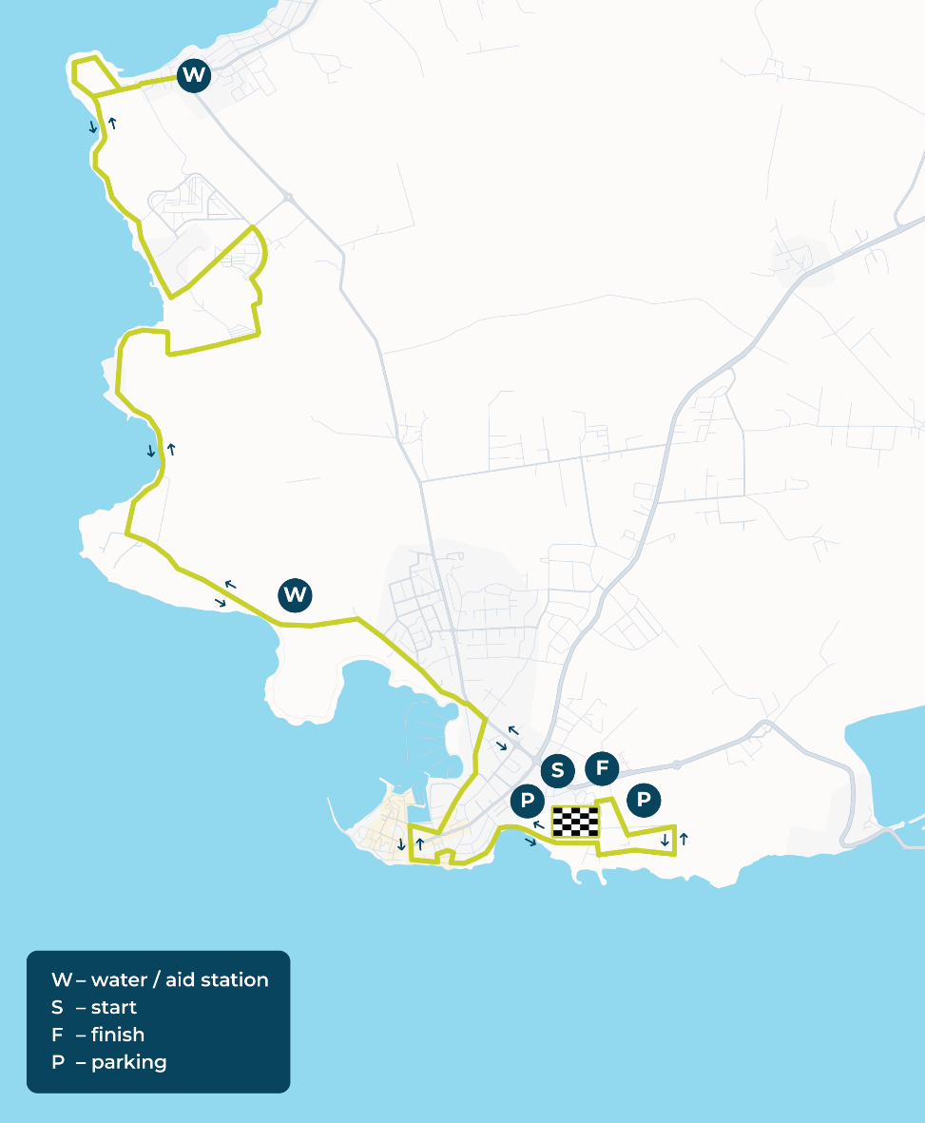
Everyone over the age of 16 on the day of the event can take part in the half-marathon. All rules and responsibilities under CONDITIONS OF PARTICIPATION apply.

10km RACE

The 10km running race is an athletic road race 10 000m long. This running race consists of one 10km lap and it has been officially measured by the Croatian Athletic Federation.

Start/finish line: In front of the Aminess Vival Maestral Hotel
Race start: 11:00 AM
Control point: 5km

Important notice:
Everyone over the age of 16 on the day of the event can take part in the race. All rules and responsibilities under CONDITIONS OF PARTICIPATION apply.

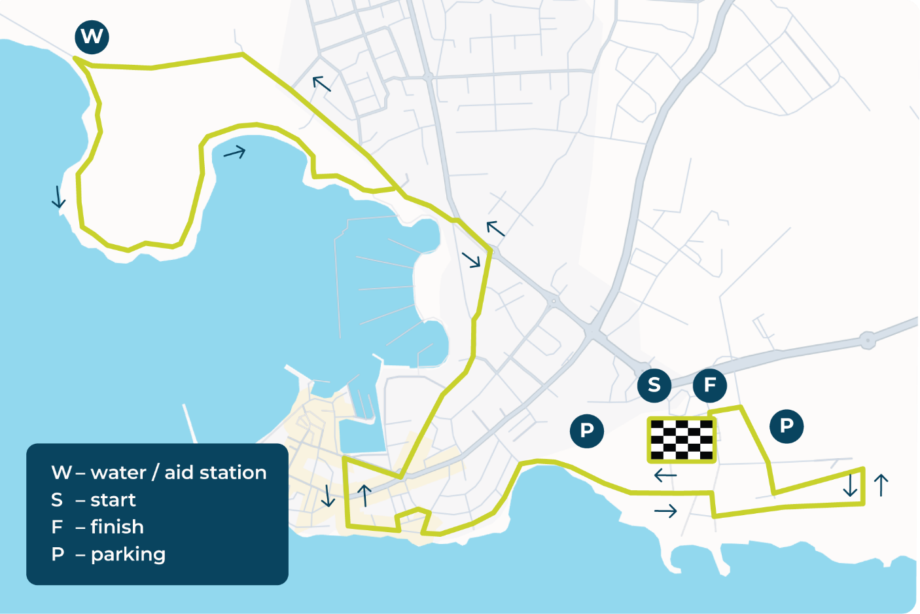
5km RACE
The 5km running race is an athletic road race 5 000m long. This running race consists of one 5km lap and it has been officially measured by the Croatian Athletic Federation.
Start/finish line: In front of the Aminess Vival Maestral Hotel
Race start: 11:30 AM
Control point: 2,5km

Important notice:
Everyone over the age of 10 on the day of the event can take part in the race. All rules and responsibilities under CONDITIONS OF PARTICIPATION apply.

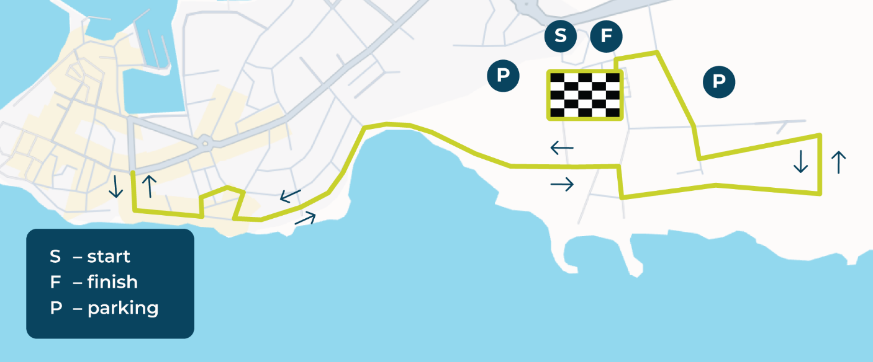

AGE CATEGORIES FOR ALL RACES
Men and Women:
• up to 19 years
• 20 to 29 years
• 30 to 39 years
• 40 to 49 years
• 50+ years

FUN RUN kids' race
Kids' run is a non-competitive race taking place in front of the Aminess Vival Maestral Hotel for children aged 3 to 8 and 9 to 10. The race will have one lap around the large car park in front of the Aminess Vival Maestral Hotel for children aged 3 to 8 and two laps for children aged 9 to 10.

Start/finish line: In front of the Aminess Vival Maestral Hotel
Race start: 10:30 AM

Important notice:
Everyone over the age of 3 on the day of the event is allowed to take part in the race. It is not necessary to register for this race beforehand.

START FEE

 | START FEE |  |  |  | CATEGORIES
RACES | 23.03. - 03.05. | 04.05. - 30.08. | 31.08. - 15.11. | On race day | M | Ž
5 km | 20 € | 28 € | 36 € | 40 € | + | +
10 km | 25 € | 33 € | 41 € | 50 € | + | +
21 km | 35 € | 45 € | 50 € | 60 € | + | +
FUN RUN | GRATIS | GRATIS | GRATIS | GRATIS
* Payments are in euro.
* Runners that sign up and pay by the 01.10. will receive the T-shirt in the desired size.

The race start fee includes:
Race organisation, gift, start number bib, finisher’s medal, on-duty medical services, beverages at refreshment stations, lunch and drinks after the race.

REGISTRATION:
Race registration closes on 15.11.2026. at 12 midnight.
Runners can sign up online on www.goadria.com.
Race fees can be paid online at www.goadria.com or on the day of the race until 10:00 o’clock.
Each runner may register for one race only.

Race registration is complete only once the registration form is filled out and the start fee has been paid – at the latest by 15.11.2026. at 12 midnight.

The registration of racers will also be also possible on the day of the race at the start line until 10:00AM. We do not guarantee the gift to runners who register and pay the registration fee on the day of the race.

By registering, competitors confirm to compete in the race at their own risk and acknowledge that they are familiar with the race rules and regulations and agree to abide by them and are aware of the potential risks associated with this competition. By registering, competitors confirm that they are medically fit and in a psychophysical condition appropriate to this type of competition. Competitors registering for the race must have health insurance coverage.

START FEE REFUNDS:
There will be no start fee refunds.

COLLECTING YOUR START PACKAGE:
- Saturday 28.11. from 2:00 PM to 6:00 PM at the Aminess Vival Maestral Hotel reception
- On the day of the race, 29.11. from 8:30AM to 10:00AM in front of the Aminess Vival Maestral Hotel

PARKING:
Parking for all race participants is provided free of charge at the sports hall.

PRIZES*:

Half-marathon 21km
Prizes for the 21km main race in the men's and women's categories:

1st place: 2 nights at a 3* or 4* Aminess facility for 2 persons
with half-board service
2nd place: access to the Aminess Vival Maestral Hotel Wellness Centre Spa Zone, gift package
3rd place: sponsored gift package

10km race
Prizes for the 10km race in the men's and women's categories:

1st place: 2 nights at a 3* or 4* Aminess facility for 2 persons
with half-board service
2nd place: access to the Aminess Vival Maestral Hotel Wellness Centre Spa Zone
3rd place: sponsored gift package

5km race
Prizes for the 5km race in the men's and women's categories:

1st place: lunch for 2 persons at the Oliveto, Aminess Vival Maestral hotel Novigrad
2nd place: access to the Aminess Vival Maestral Hotel Wellness Centre Spa Zone
3rd place: sponsored gift package

*Subject to conditions and instructions stated in the winner's voucher.

Age Categories
The prize is awarded for 1st place in each age category, for both male and female categories.

ORGANIZER’S DISCLAIMER OF LIABILITY
Each race participant, by registering and participating, accepts the following conditions:
- By registering and participating, the participant confirms that they compete in the race entirely at their own risk, fully aware that participation in this race involves potential hazards, including the risk of various types of bodily injury and possible death.
- The participant accepts that the Organizer is not responsible for any form of damage incurred as a result of participation in the event, whether directly or indirectly, separately or in connection, caused by their own negligence or fault, or by the negligence or fault of other participants or third parties, before, during, or after the said event.
- The participant is responsible for any form of damage caused to third parties that they have caused or contributed to through their own negligence or fault.
- The participant is obliged, during the race and immediately before and after it, to comply with the officially published rules, instructions for safe conduct, and conditions of participation issued by the Organizer, as well as the instructions of judges, marshals, and other personnel involved in the organization of the race on-site.
- The participant waives the right to claim any form of compensation from the Organizer through legal action for damages arising from participation in the race.

CONDITIONS OF PARTICIPATION:
By registering and participating, all participants confirm that they compete in the race entirely at their own risk (for minors, this is confirmed by a parent or guardian), that they are familiar with the race rules which they will follow, and that they are aware that participation in this race involves potential hazards, including the risk of various types of bodily injuries and possible death.
By registering for the race, the participant waives the possibility of transferring responsibility to the race organizer and confirms their health condition and readiness to complete the race.
The organizer has provided medical support in accordance with the rules for conducting road running events.

Refreshments will be provided at the start of the race, during the race in accordance with IAAF and HAS propositions related to road running and at the finish line. Additional refreshments will also be provided at the finish line. Electronic chip timing will be used. All results will be published immediately after the race on the organiser’s official website.

All competitors will have their net (chip start) and gross time (the time measured from starter’s signal to start the race to the moment competitors cross the finish line).
Race bib numbers have to be worn on the chest and they need to be visible during the whole race. Along with the bib, competitors need to have their chips. If the chip is lacking, their result will not be recorded. In case competitors do not adhere to the rules, they may be disqualified.
Time limit is 3:00 h (8:32/km).

Unofficial race results will be published immediately after the end of the race. There will be a three-day appeal period starting from the publishing of the unofficial results. Once the appeal period expires, race results will become official.

Roads will be closed for traffic and there will be bike escort in front of the first group of runners.
At crossings and critical points, the competitors will be directed by race stewards. All race participants compete at their own risk and should respect instructions from race stewards on the route.

If not otherwise specified, Croatian Athletic Federation rules harmonised with IAAF rules shall apply.

By registering for the race, competitors confirm that the data they have provided are accurate and they allow the organiser to use the data for the purposes of organisation and promotion of the event one year after the race.

The organizer will publicly release the information of registered participants and the race results.
The organizer will use photographs taken during, immediately before, and after the race for the purpose of promoting the event and the organizer.

The RACE will go on regardless of the weather!

